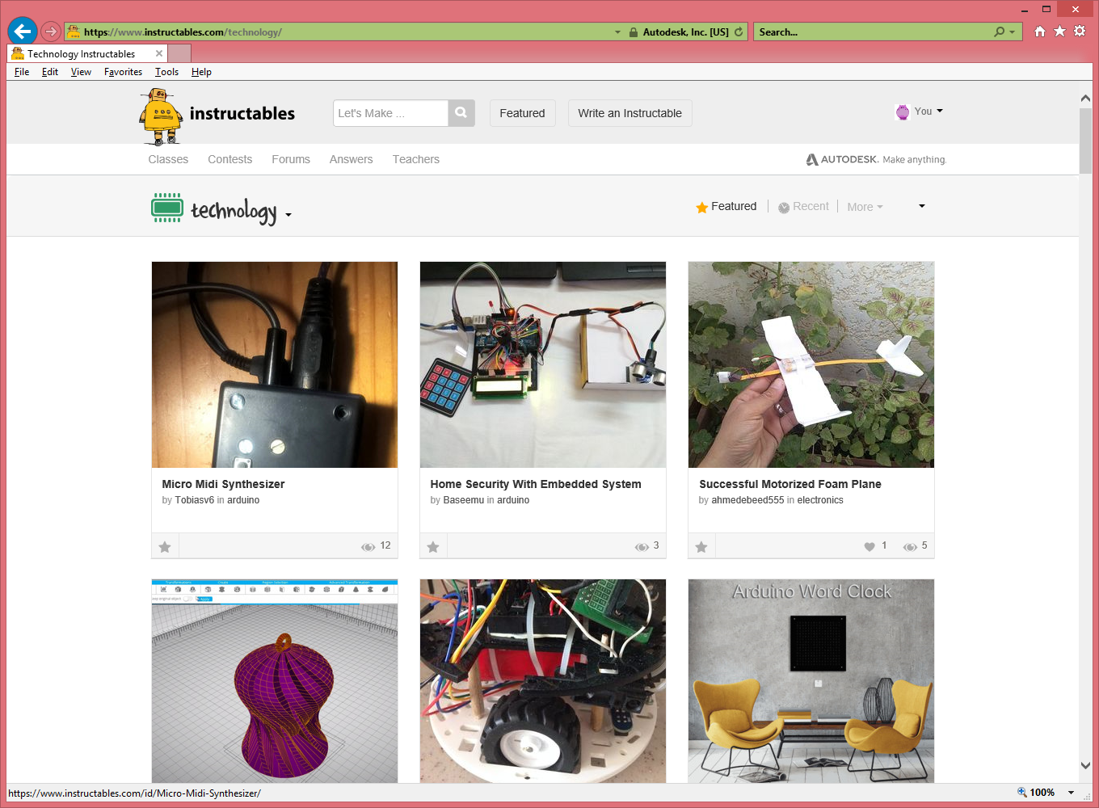

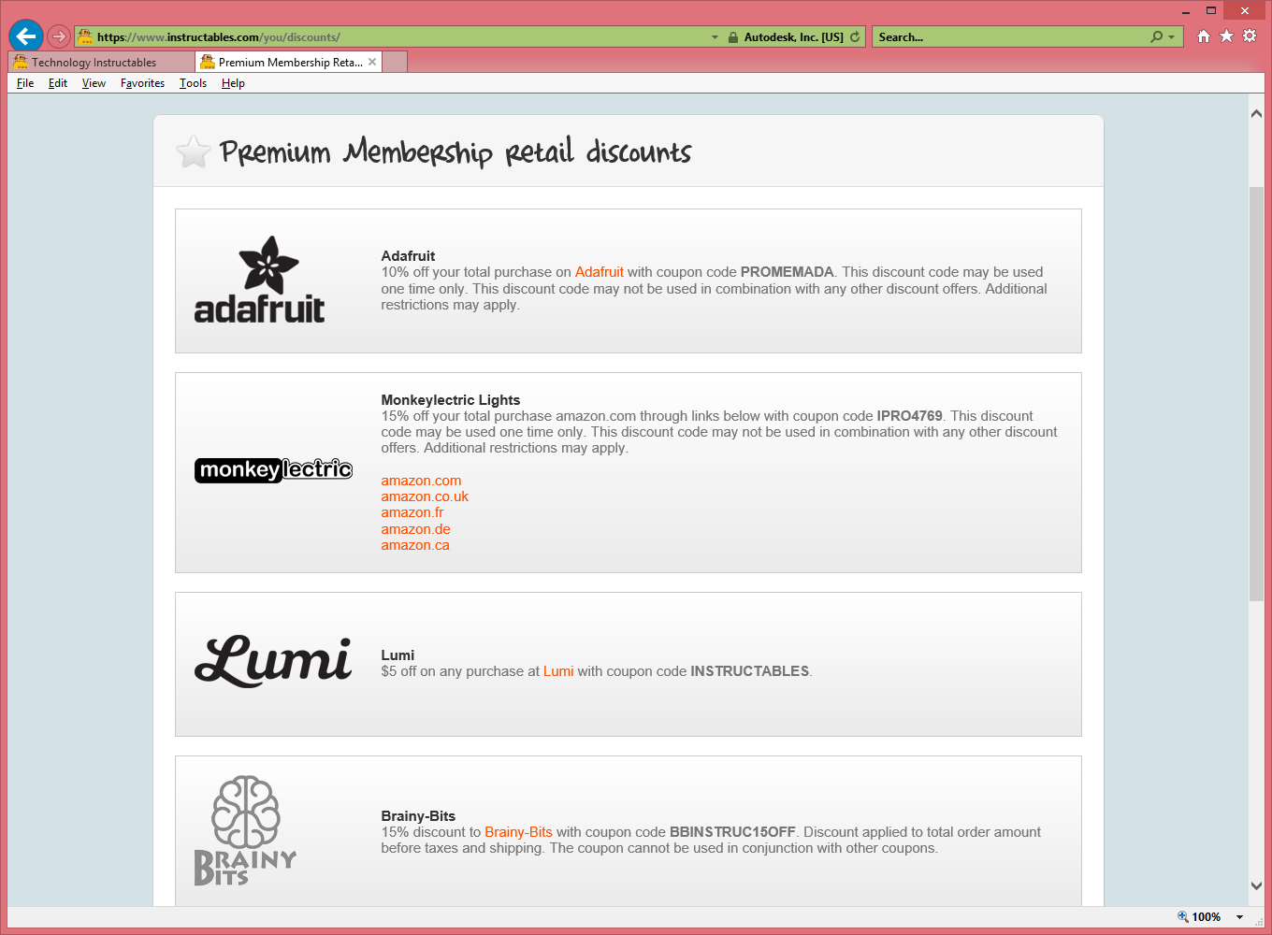

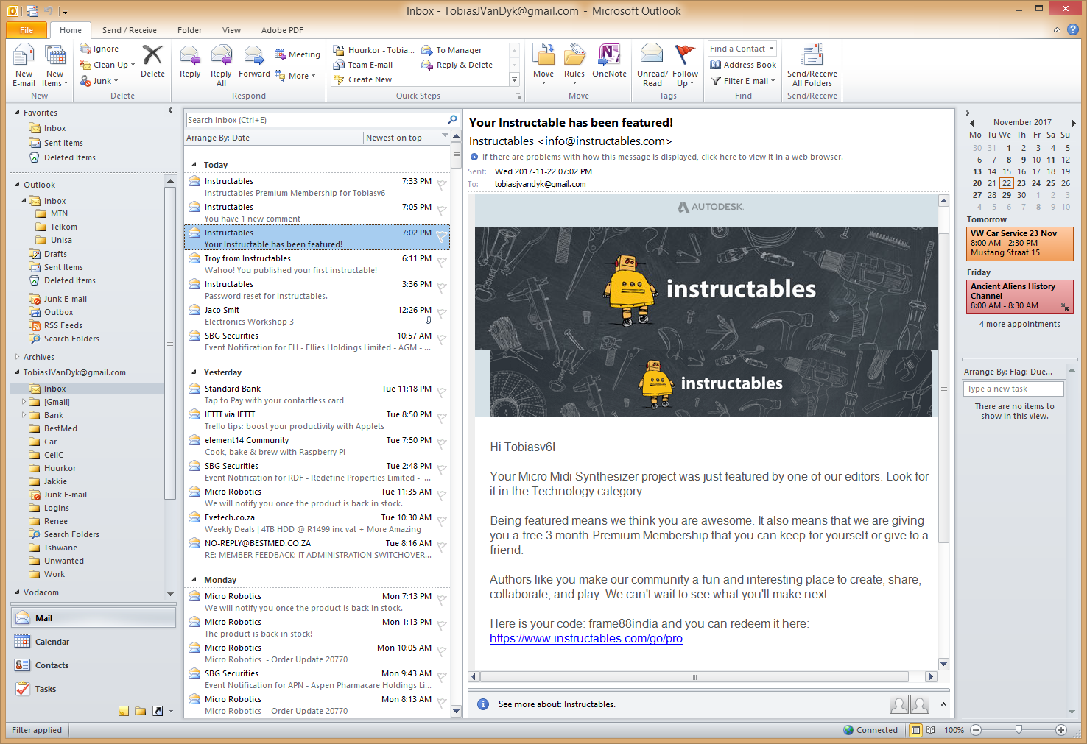

Hi Tobiasv6!  
  
Your Micro Midi Synthesizer project was just featured by one of our editors. Look for it in the Technology category.  
  
Being featured means we think you are awesome. It also means that we are giving you a free 3 month Premium Membership that you can keep for yourself or give to a friend.  
  
Authors like you make our community a fun and interesting place to create, share, collaborate, and play. We can't wait to see what you'll make next.  
  
Here is your code: frame88india and you can redeem it here: <https://www.instructables.com/go/pro>



  
  
  